# RAP-Introduction:

<https://youtu.be/44V4ybbbP_s?list=PLpS9_oEgVsZ0XvUXOa8td8vjMbG0p5w9V>

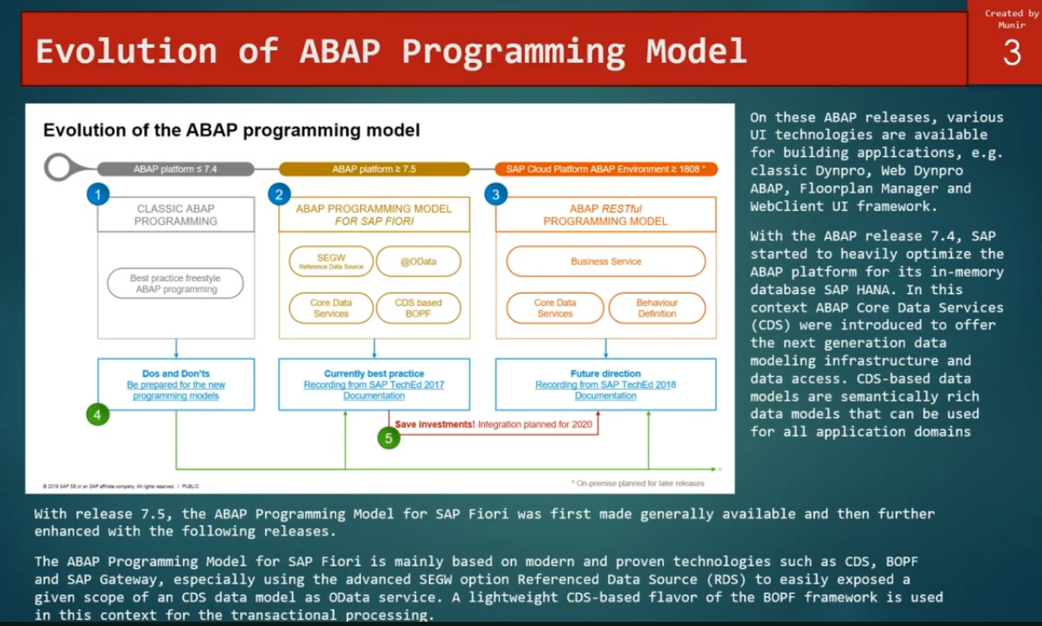

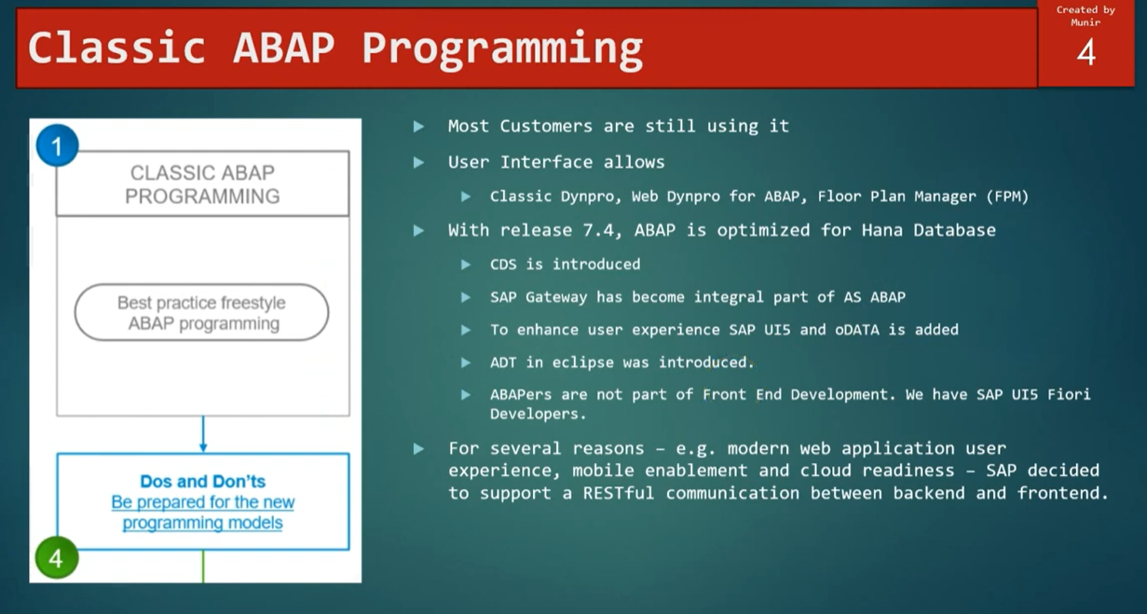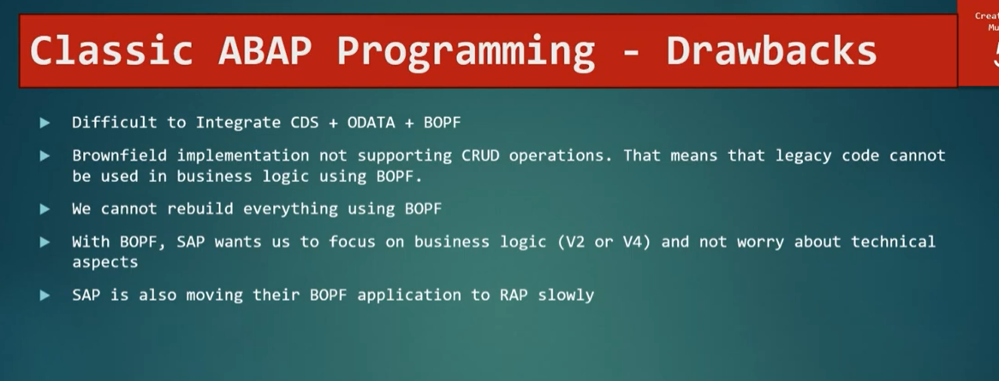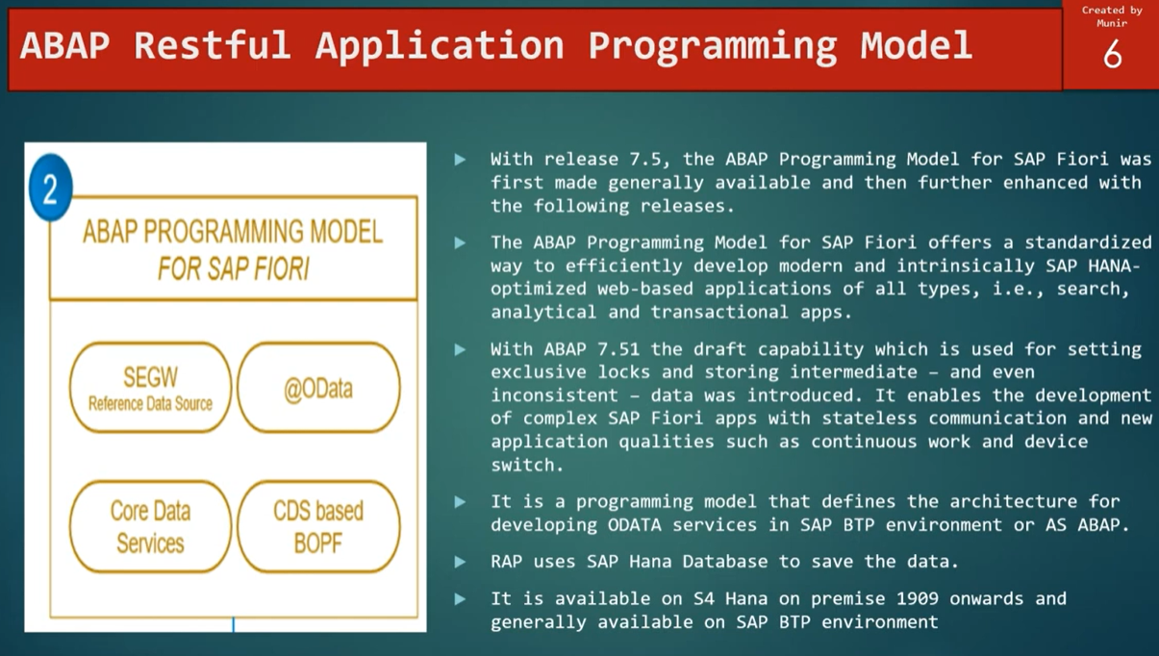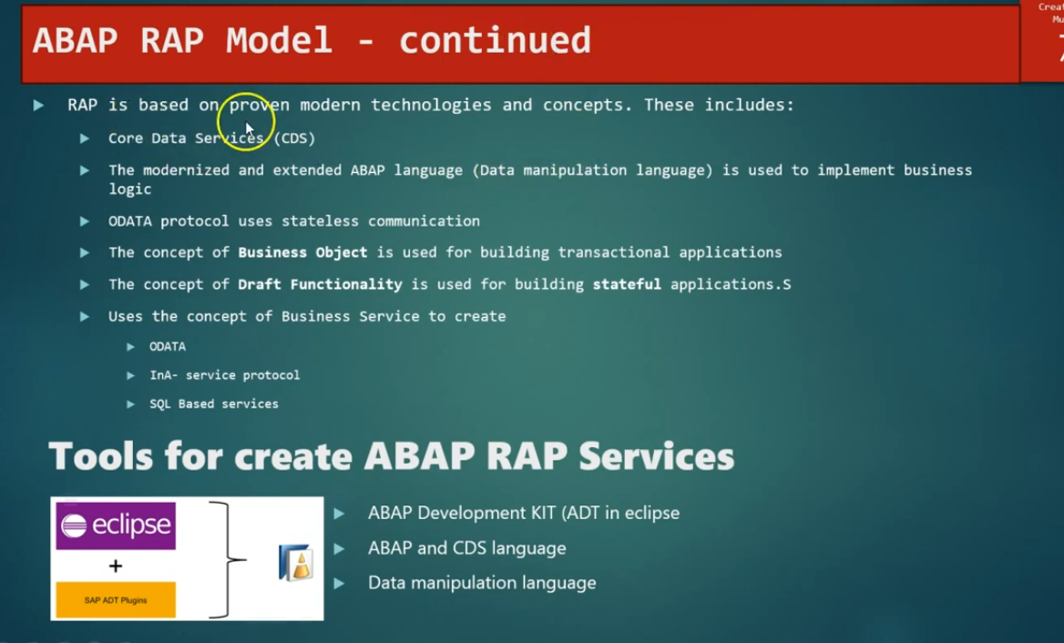

# Overview-RAP Architecture:

<https://youtu.be/ElgDksJnuzw?list=PLpS9_oEgVsZ0XvUXOa8td8vjMbG0p5w9V>

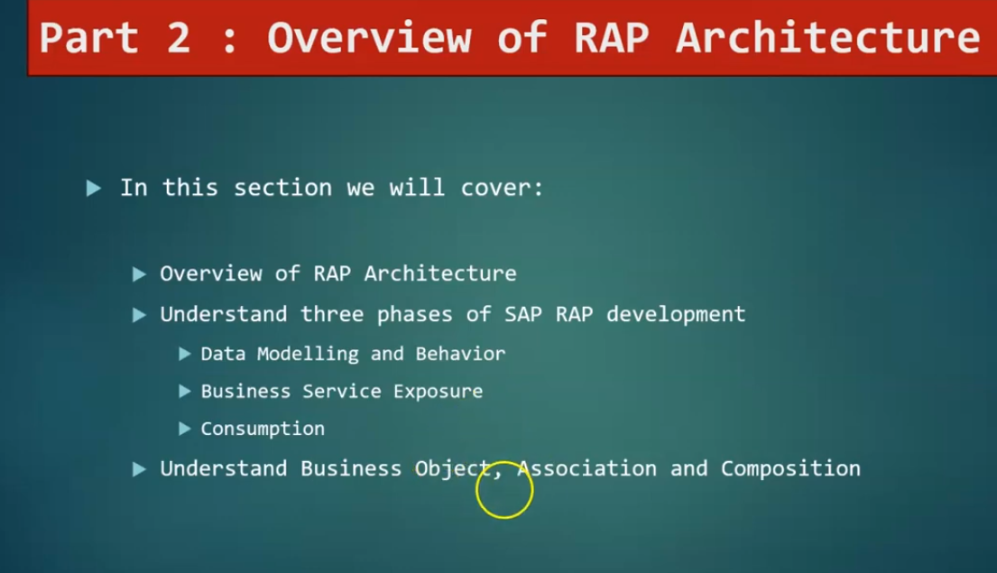

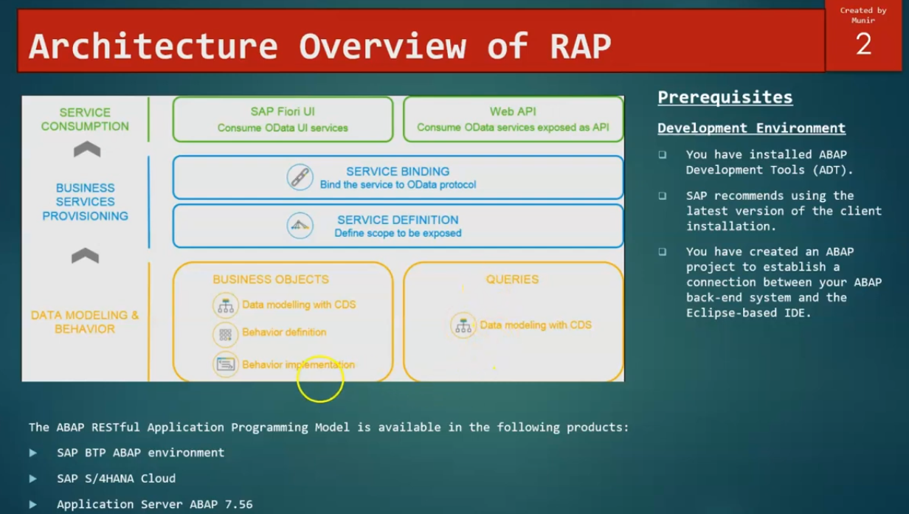

## Data Modeling and Behavior:

1. Data Modeling define with CDS.
2. On top of the Data Modleing, we can create the behavior definition and Implementation.
3. CDS 🡪 Data Modeling 🡪Behavior Definition 🡪Behavior Implementation
4. Once data model and Behavior completed, it moves to the Business service Provisioning.

## Business Service and Provisioning:

1. Service Definition.
2. Service Binding.

### Service definition:

* Service definition scope, that is exposed on top of behavior definition

### Service Binding:

* Actual create the odata protocol, that can be used to create the Odata service and that cane used in FIORI UI and Web API.

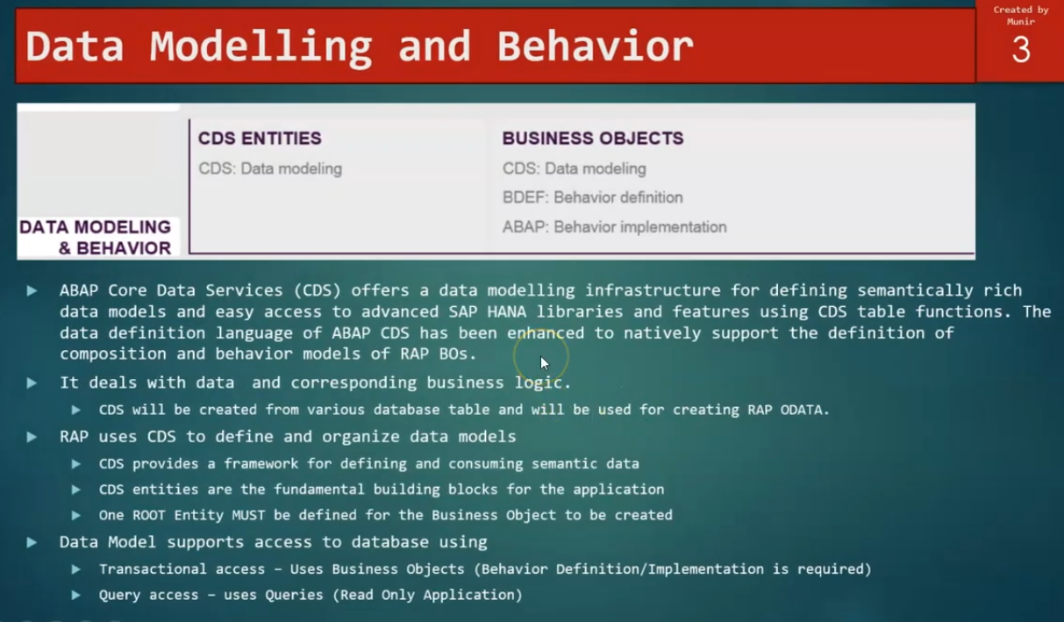

## What is business object?

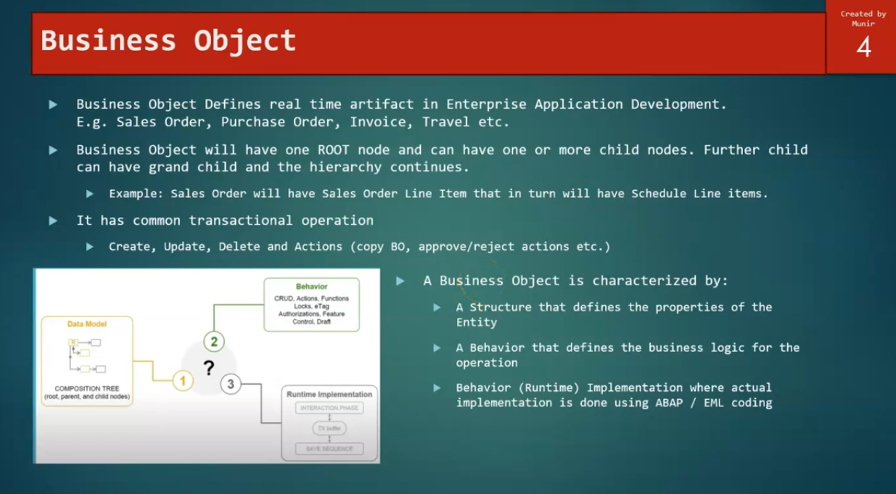

1. Business object has one root node.
2. On top of Data Model/Business object, we can define the behavior definition and behavior will have the crud operations, Actions, Locks, Authorizations.. etc
3. Once behavior defined, we can create the service definition and service binding and these will actual used in runtime implementation to execute the business logic, while creating the behavior definition, there are two ways of doing these implementation,
4. Managed implementation.
5. Unmanaged Implementation.

## Runtime Implementation:

Behavior(Runtime Implementation) implementation where actual implementation is done using ABAP/EML Coding.

## Business Object-Composition Tree

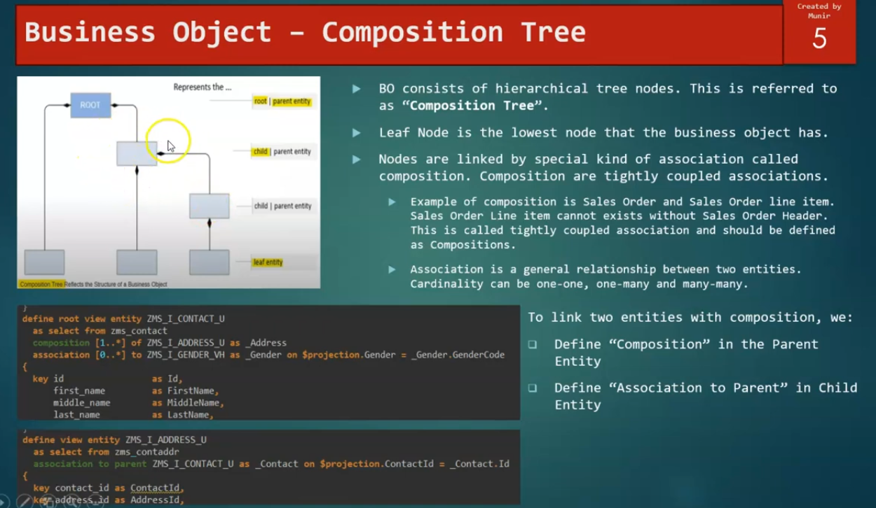

## Composition:

For composition: cardinality is [1..*]- one to many.

1. Define “composition” in the parent entity. - Composition [1..*] of <child entity>
2. Define “Association to Parent” in child entity. Association to parent <parent entity>

Ex:

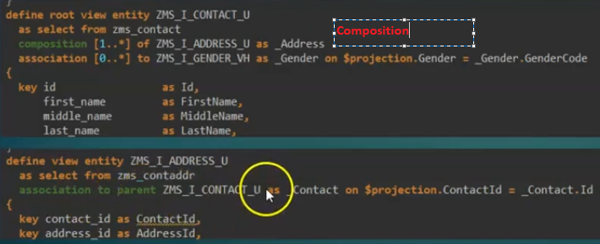

## Behavior Definition:

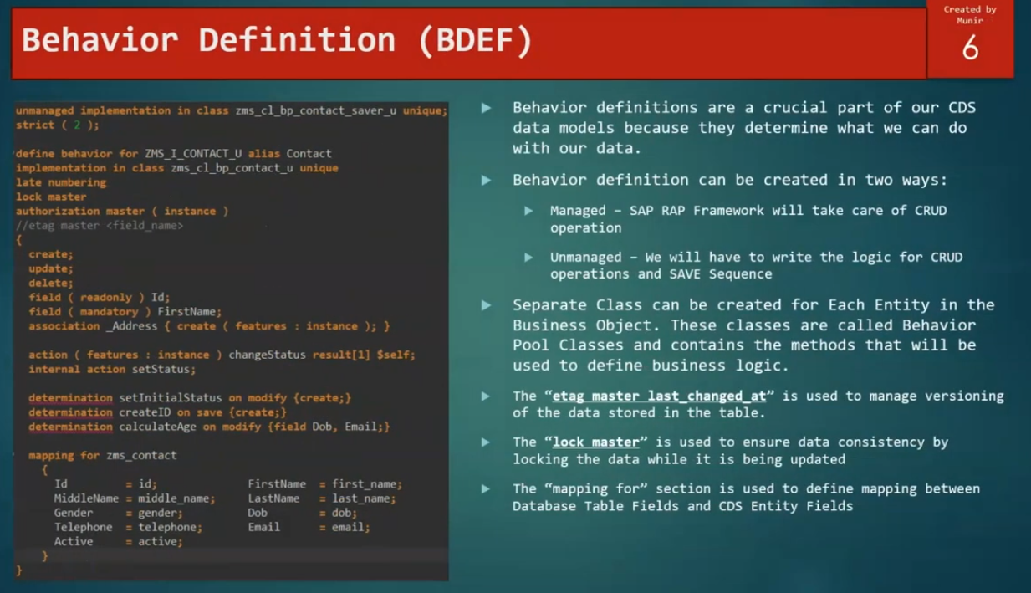

1. Association to the _Address, address will be always created using the associations to the contact entity(ZMS_I_CONTACT_U).
2. In Behavior definition, we can use field read only/mandatory/action/determination/mapping .
3. In mapping <cds alsias field name> =< db field name>
4. In managed scenario, class implementation not required, it is handled by RAP frame work.
5. In unmanaged scenario, it is required to implement the class for CRUD operations.
6. ETAG master <field name>- if user1 is editing the data in one entity, and user2 will not allow to edit the data, it will through the error in popup.

### Behavior definition structure

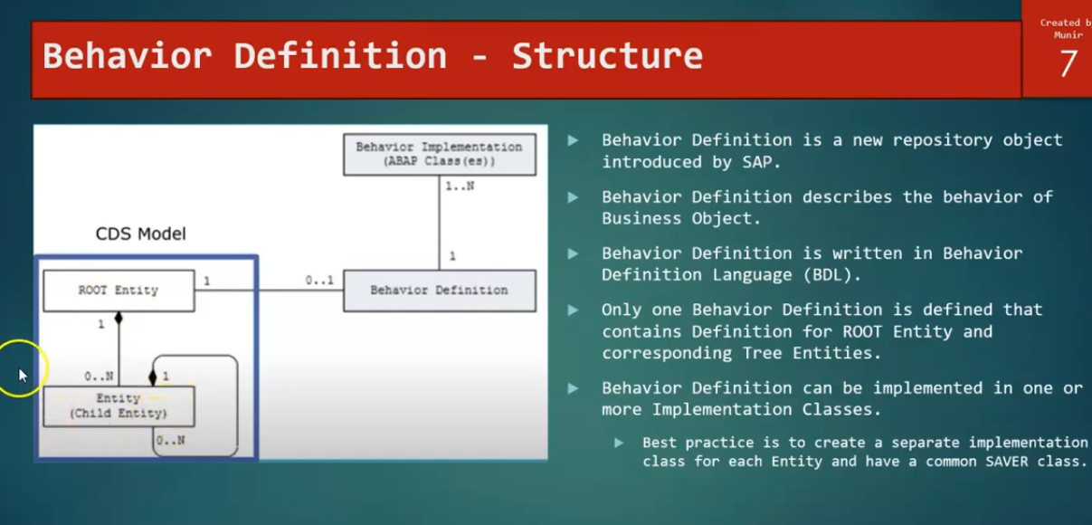

### Behavior definition Characteristics:

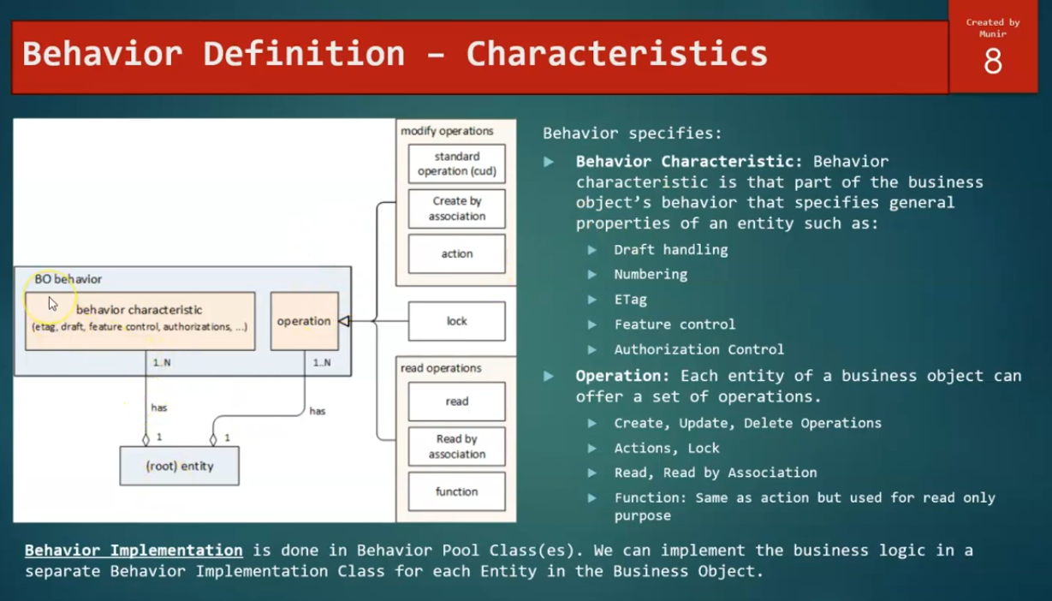

Behavior definition at runtime